HILLY FIELDS FOOTBALL CLUB
SEASON 17: 1983-84
FIRST TEAM:
BECKENHAM LEAGUE:
P W D L F A Pts Pos
Division 1 16 4 3 9 24 4 11 6th
Beckenham League Cup 7 5 1 1 23 17 FINAL
Beckenham Hospital Cup 1 0 0 1 2 4
Christchurch Cup 2 1 0 1 4 11
Friendly 7 3 1 3 18 24
TOTAL 33 13 5 15 71 100

Apps Gls Apps Gls
Steve Banks 27 0 John McGilvray 26 2
Vic Banton 2 0 Kevin Mitchell 1 0
Geoff Beeson 9 0 Pat Mulligan 2 0
Paul Cowdrey 7 0 Jim Murphy 1 0
Steve Davis 2 1 Dave Norman 26 24
Herbie Farraday 1 0 John O'Regan 14 4
Terry Felvus 15 0 Steve Reeves 2 0
Jim Flood 29 0 Charlie Shoppee 23 0
Dave Ford 25 5 Albert St Clair 8 4
Steve Ford 23 12 Rick Symes 1 0
Keith Foster 10 1 Andy Tipping 19 1
Tim Fuller 1 0 Mario Vaz 1 0
Larry Garnham 19 1 Winston Vaz 1 0
Billy Green 1 0 Colin Walker 5 1
Eddie Hicken 1 0 Allen Webber 1 0
Malcolm Hill 2 0 Nick Woolhouse 2 0
Graham Hooker 1 1 Dave Wright 4 1
Mike Jefferys 9 2 Chris Yusuf 30 8
Steve Jordan 16 2 OG 1

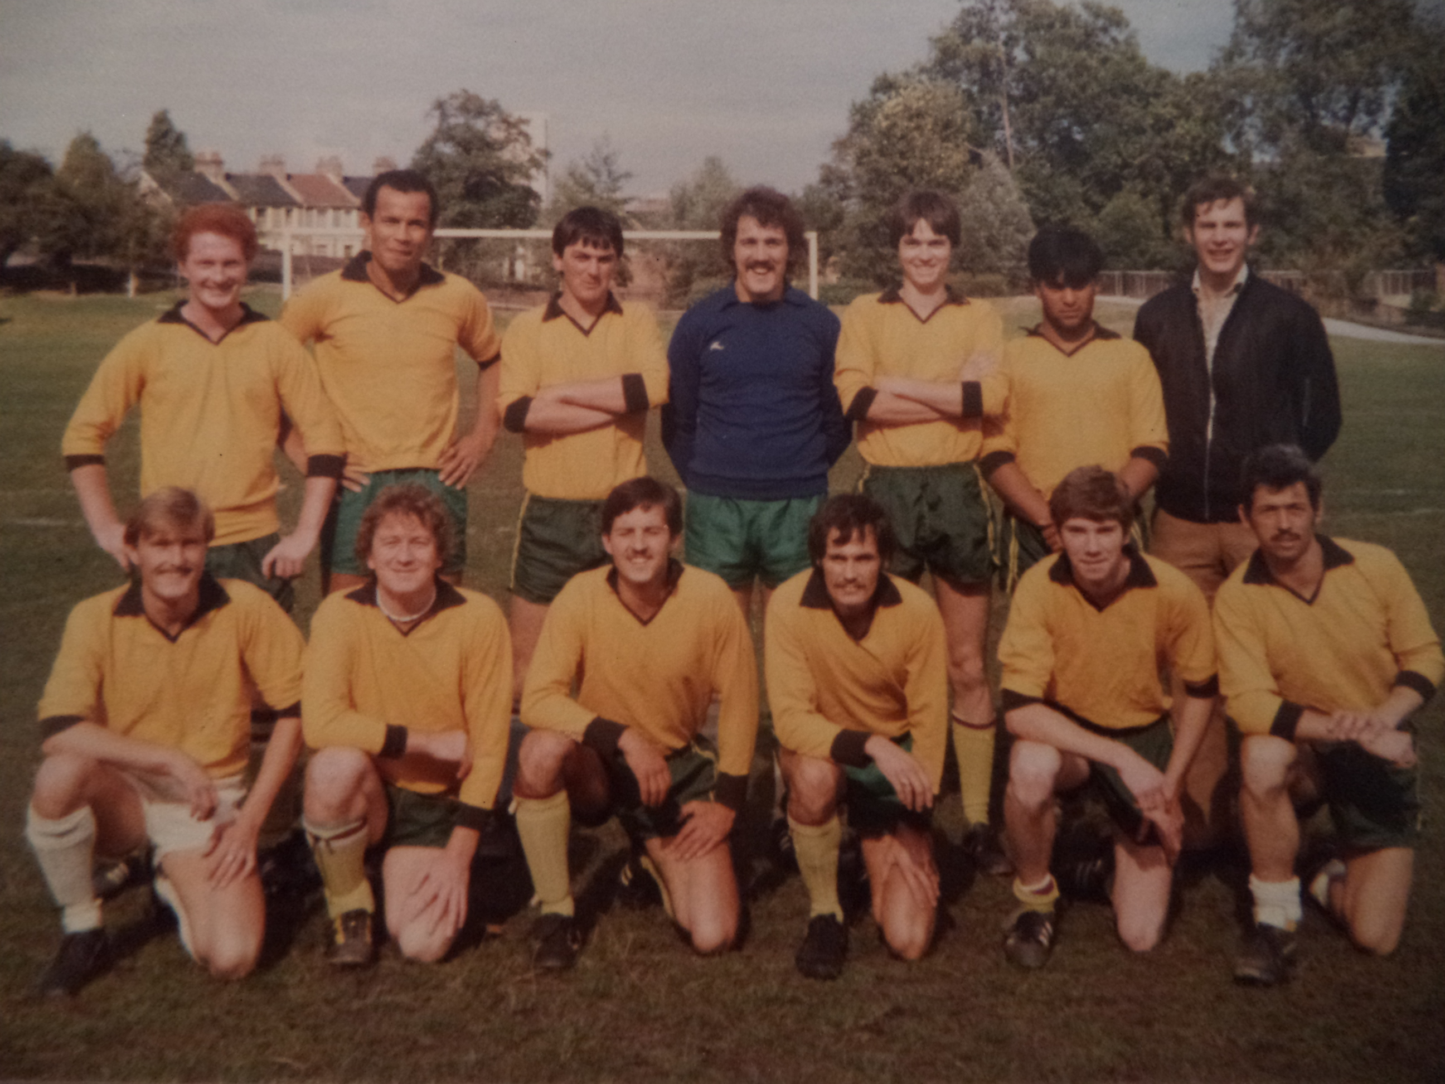
L-R Back: Jim Flood, Chris Yusuf, Andy Tipping, Steve Reeves, Dave Ford, Herbie Farraday, Keith Foster L-R Front: Mike Jeffereys, Paul Cowdrey, Charlie Shoppee, John McGilvray, John O'Regan, Dave Wright

